There are **N** compartments. A train exists with **N*8** seats in total. **2 seats(Lower,Upper)** on **right** and **6 seats(2 Upper, 2 Lower, 2 Middle)** on **left**, total **8 seats** in each compartment**.**

Example for 3 Compartments:-

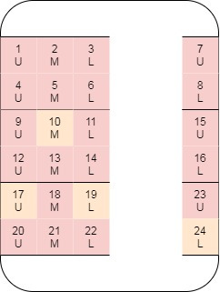

**Function Description**

The first line of input will tell **N**, the number of compartments.

The second line of input will tell all the seats that are already booked.

The third line is for personal preference(Compartment (1/2/3/N) , Left/Right(L/R/N) , Upper/Middle/Lower (U/M/L/N), the character “N” represents no preference regarding the field i.e., the sequence “N N N” represents no preference at all).

You have to show all the seats available according to their preferences.

The order of result should be, Compartment 1-Left Side-Upper > Compartment 1-Right Side-Upper > Compartment 1-Left Side-Middle > Compartment 1-Left Side-Lower and so on.

**Input Format**

2

3 5 6 8 11 13 14 15 16

N R N

**Constraints**

1<=N<=10^{4}

**Output Format**

[7]

**Sample Input**

2

3 5 6 8 11 13 14 15 16

N N N

**Sample Output**

[1, 4, 7, 2, 9, 12, 10]

**Explanation**

There are **2** Compartments in total out of which **3,5,6,8,11,13,14,15,16** are booked. Hence, the available seats are **1,2,4,7,9,10,12**. As there are no preference to seat booking we only needed to display all the available seats in priority order. When arranged in the priority order, the result is **1, 4, 7, 2, 9, 12, 10**.